# NEPR 2017-07: Compression Test Protocols

## Tensiometer Settings *CC COMPRESSION*

For testing the compressive strength of the material according standard CC procedure. Test samples in order of the bend test to combine the data export.

|  |  |  |
| --- | --- | --- |
| Sample size | 140 x 40 | mm |
| Speed | 0.025 | mm/min |
| Stroke Length | 3.0 | mm |
| Pre-load | 200 | N |

## Testing Equipment

The 40 x 140mm jig should be used for marking out samples. The standard compression jig should be used on the tensiometer.

## Sample Naming System

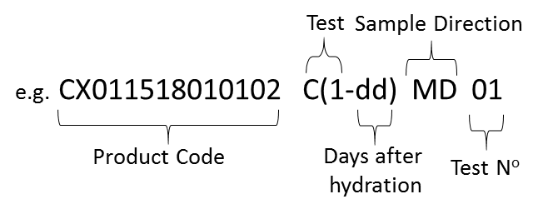

## Data Export

Compression tests should be carried out directly after a bend test. As a result, the data can be exported in the same excel sheet.

Open the relevant ‘YYMMDD Bend Test’. Add a row under the named columns, and write in the compression results in MPa, taken straight from the tensiometer program.

The file should be named ‘YYMMDD Bend Test’, each column labelled, and saved in *Lab RD > NEPR 2017-07 TESTING > Excel Data Point Export*

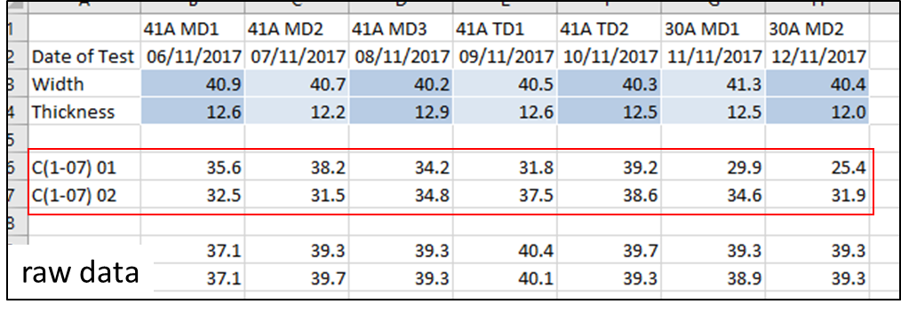

Compression Test Protocol

|  |  |
| --- | --- |
| C(1-dd) Standard CC set compression test |  |